The question of atheism was asked by WIN-Gallup International in a similar survey that was conducted in 2005. (We assume here that sample sizes have remained the same.) Table 4 on page 13 of the report summarizes survey results from 2005 and 2012 for 39 countries.

**1.Answer the following two questions using the inference function. As always, write out the hypotheses for any tests you conduct and outline the status of the conditions for inference. Explain the inference in plain English!!**

**a. Is there convincing evidence that Spain has seen a change in its atheism index between 2005 and 2012?  
Hint: Create a new data set for respondents from Spain. Form confidence intervals for the true proportion of athiests in both years, and determine whether they overlap.**

R code

|  |
| --- |
| load(url('http://s3.amazonaws.com/assets.datacamp.com/course/dasi/atheism.RData')) names(atheism) spain = subset(atheism, atheism$nationality == "Spain") proportion = sum(spain$response == 'atheist') / length(spain$response) inference(spain$response, spain$year, est = "proportion", type = "ci", method = "theoretical", success = "atheist") |

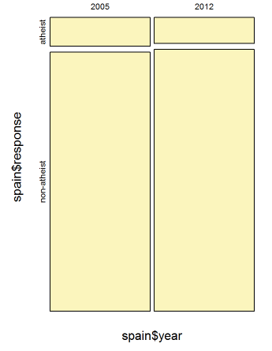

Output

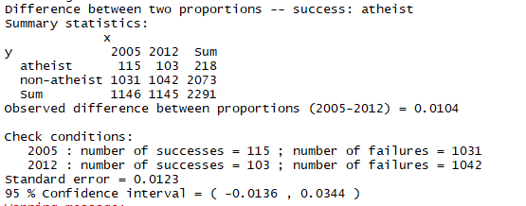

Because confidence interval (-0.0136, 0.0344) contains 0, so convincing evident about a change of Spain in atheism index between 2005 and 2012 is False.

**b. Is there convincing evidence that the United States has seen a change in its atheism index between 2005 and 2012?**

**R Code**

|  |
| --- |
| usa = subset(atheism, atheism$nationality == "United States") proportion = sum(usa$response == 'atheist') / length(usa$response) inference(usa$response, usa$year, est = "proportion", type = "ci", method = "theoretical", success = "atheist") |

**Output**

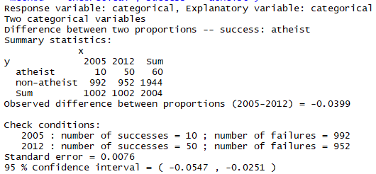



We can see confident interval 95% (-0.0547,-0.0251), too different compare to 0. So we conclude there is convincing evident that USA has a change in atheism index between 2005 and 2012.

**2.If in fact there has been no change in the atheism index in the countries listed in Table 4, in how many of those countries would you expect to detect a change (at a significance level of 0.05) simply by chance?**Hint: Look in the textbook index under Type 1 error.

Because there are 39 countries in the table

**0.05 * 39 = 1.95**

3.Suppose you're hired by the local government to estimate the proportion of residents that attend a religious service on a weekly basis. According to the guidelines, the estimate must have a margin of error no greater than 1% with 95% confidence. You have no idea what to expect for pp. How many people would you have to sample to ensure that you are within the guidelines?  
Hint: Refer to your plot of the relationship between pp and margin of error. Do not use the data set to answer this question.

R Code

|  |
| --- |
| p <-0.5 #confidence is 95%, so we have z = 1.96 z <-1.96 #margin of error is not greater than 1% me <-0.01  n<- (z*z*p*(1-p))/(me*me) n |

Output

9604

So at least we need 9604 people for sample